**Nodaway County Economic Development Project**

By: Matthew Wholey and Liz Conard

We were given the task of creating a system to predict the effect that manufacturing companies had on nodaway county economic conditions. After contemplating how to approach this problem, we decided on an alternate route. This problem was too big for two people to solve. We realized that we needed to break this task down into something more attainable.

Once we had reached this realization, we analyzed the data collected from last years group. It was important to us that we understood the data they collected. In analyzing, however, we noticed some interesting errors. The first thing we noticed was that they had not adjusted for inflation. We have data from 2009 which doesn’t seem that far back, but adjusting for inflation is important, especially with a nine year gap.

The other interesting thing that struck us was that they did not factor in population of individual counties. When we tried to graph the data we were getting some huge outliers, one in particular being Cook County, Illinois. That county contains Chicago, whose population is nowhere close to that of Nodaway County.

After seeing these errors we knew we needed to get back down to the basics and make sure the results we were finding were accurate. We wanted to lay the groundwork so that this data could be added to and built off of for future years. While 9 years is enough to account for inflation, it is not enough time to accurately predict the effect of manufacturing companies on economic growth, unfortunately.

What we were able to find…

**2010**

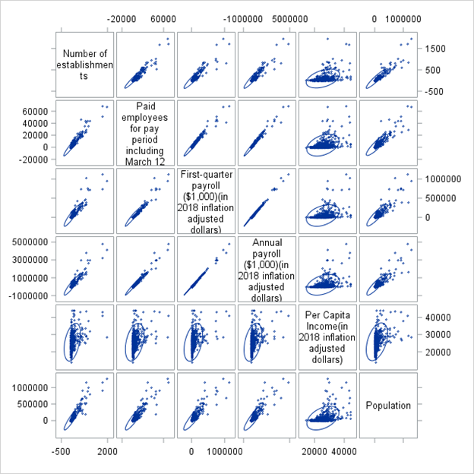

**2011**

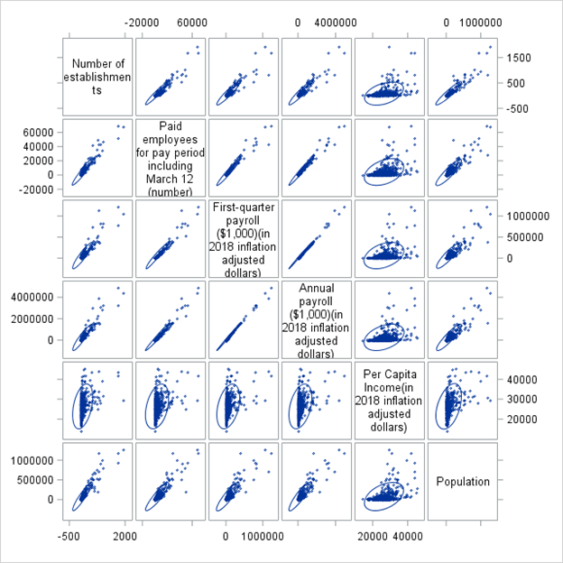

**2012**

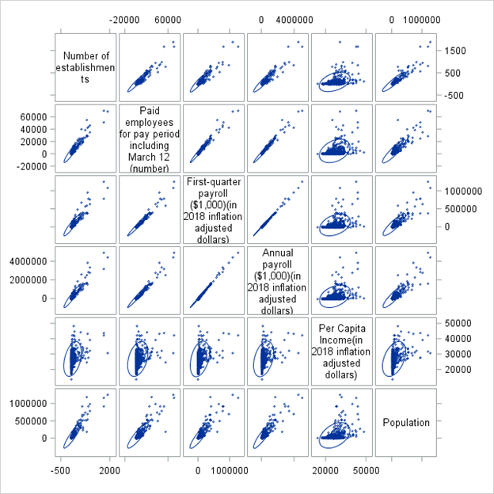

**2013**

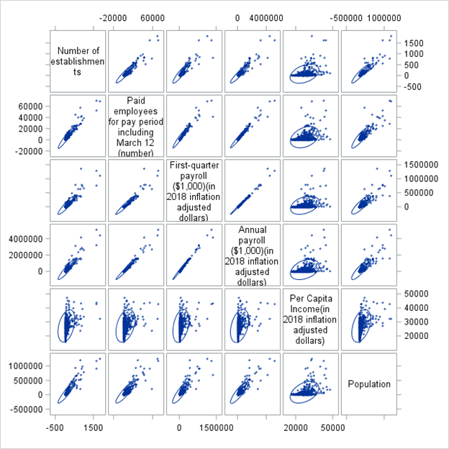

**2014**

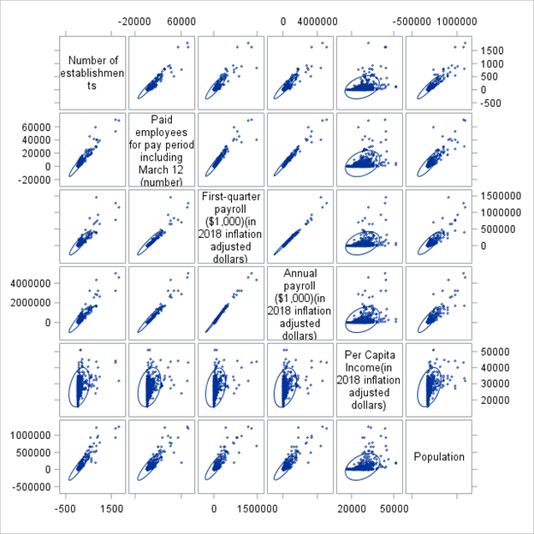

**2015**

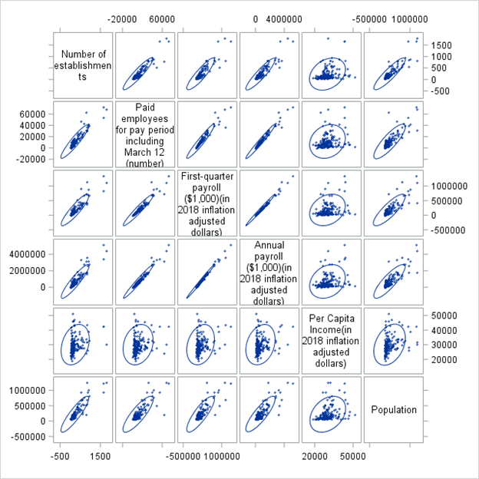

We separated the data out by year and graphed the scatterplot matrices. In all years, the number of manufacturing establishments seems to have a positive correlation with all factors besides per capita income. The per capita income factor really threw us for a loop. It did not seem to have a strong correlation with any of the other factors, including annual payroll.

Next, we were curious if population had any effect on these results. So, we took all the data from 2014 and did new scatterplot matrices. This time, we separated the data by populations greater than 30,000, populations less than 15,000 and populations in between. These were our results.

**Populations > 30,000**

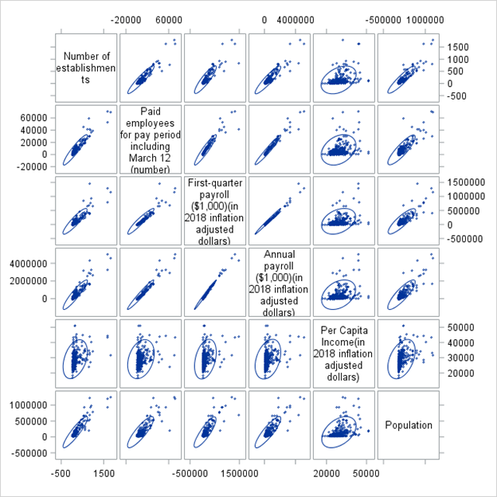

**15,000 < Populations < 30,000**

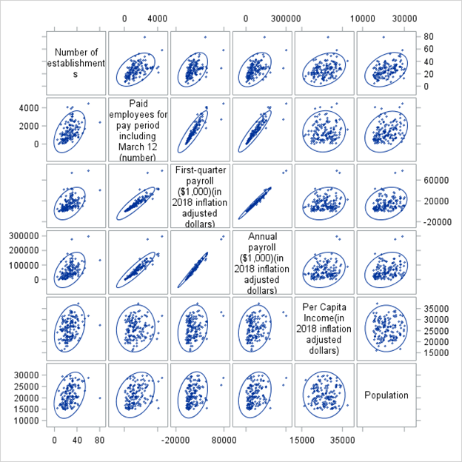

**Populations < 15,000**

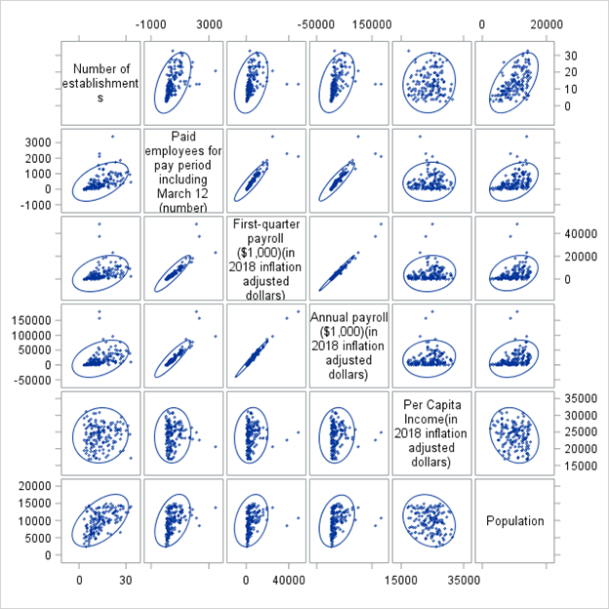

What is interesting about these scatterplots is the change in correlations involving number of manufacturing companies as population changes. When the population is high, manufacturing companies are still showing strong correlations with all of the factors besides PCI. When you get to the middle population range, where Nodaway county lies, you still see slight correlation, but nowhere near as significant. Finally, looking at the low population counties, they seem to have more of a correlation with number of manufacturing companies than the middle population counties, but less correlation than the high population counties. The strange thing about this is that the low population counties have a steeper correlation with manufacturing companies than the other two. So it seems like adding manufacturing companies makes much more of a difference in small counties than it does in larger ones.

**Manufacturing Employees by total Population change from 2010-2015**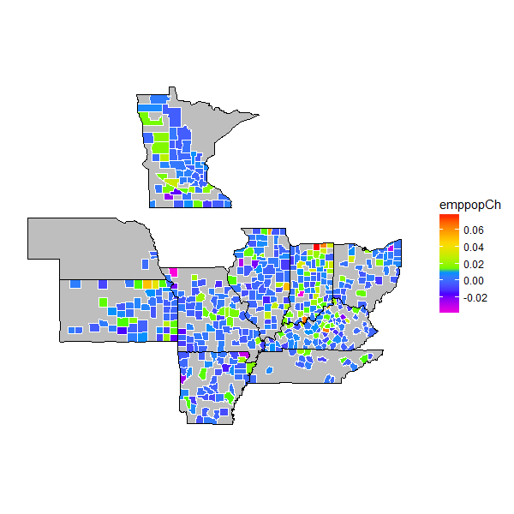

Green is above 0 (increase in employees per population). Blue is below 0 (decrease). We can see that most of the counties we have data on have a negative change in employee population. There are a few counties with large changes in purple or red. Indiana appears to be doing better.

**Manufacturing Employees per Manufacturing Establishments change from 2010-2015**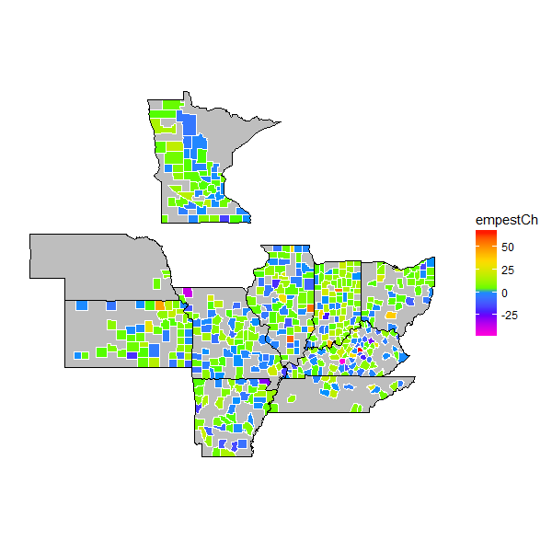

Here, we see the change in manufacturing employees per manufacturing facility. This, interestingly enough, is mostly in the positive range with the majority of counties in the green.

The disparity between this graph and the previous one is interesting. The negative nature of the first graph tells us that either population is increasing or manufacturing employees is decreasing. The second graph is mostly positive which tells us that either manufacturing employees is increasing or that number of establishments is decreasing. Since our data is over the same range of time and in the same place, we can say that the number of manufacturing employees cannot be increasing and decreasing at the same time and thus population is increasing, and the number of manufacturing facilities is slowly decreasing.

References:

https://factfinder.census.gov/